MANUAL: How to choose a subject for the next semester using the eHMS system.

- Log into the Virtual Dean’s Office
1.1 Start the browser (Mozilla Firefox recommended, IE not recommended).
1.2 Enter the address:https://ehms.sggw.edu.pl and log into using the user ID and eHMS password.

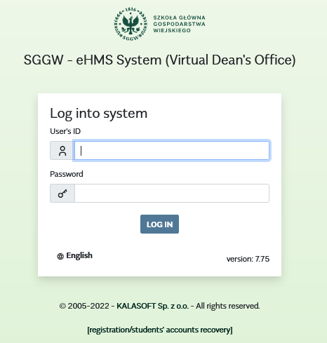

Note!
If you do not remember your password or User ID number (UID), you should use the option [registration/students’ account recovery]. Then you must fill in the form. After the form is filled in correctly, the system provides you with the UID and password.

2. Open the Choice of offer window
2.1. After you successfully logged into the eHMS, click the [my schedule] tab.
2.2. Choose the last option from the list [Teaching offers]. Then pick up the correct academic year and semester in the [Choice of offer] window, and click [Choose]. You will see the Basic schedule offer below the Go to text.

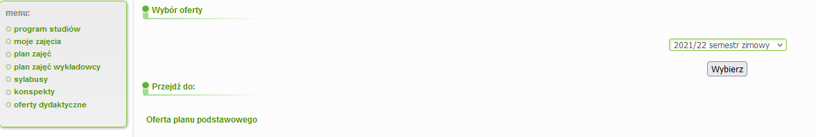

2.3 Click on the Basic schedule offer.
You will see the window with the courses to choose.
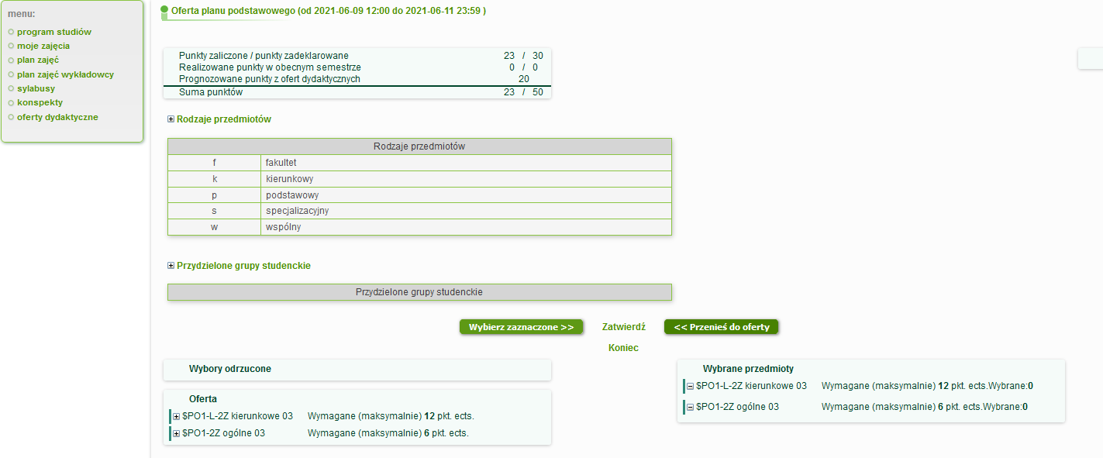

2.4. Teaching offers
Information available on “Basic schedule offer” screen:
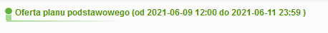
You can see the subject availability, and possibility to change your choice.
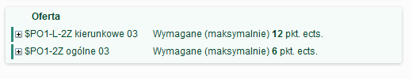
Offer - you can see a list of subjects to make a choice.
As an example shows, subjects should be selected from the "$PO1-L-2Z major" drop-down list for max. 12 ECTS points, and from the "$PO1-2Z basic” list for max. 6 ECTS points.
To view the list of subjects, click the [+] button next to the list you wish to choose.

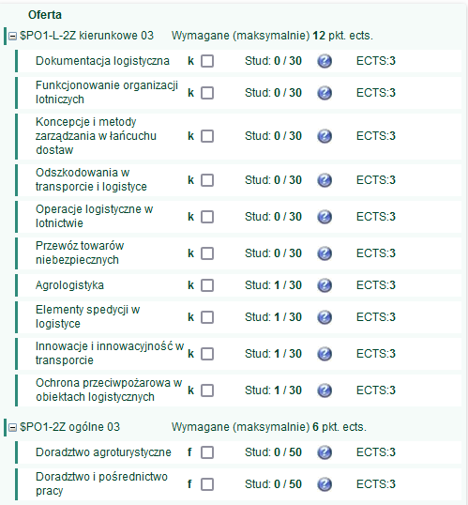
Information next to the subject’s name:
Stud: 0/10 - no one enrolled the course, max. number of students -10.

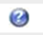
- contains additional information about the subject, after clicking on the icon, the "Information about the subject" appears
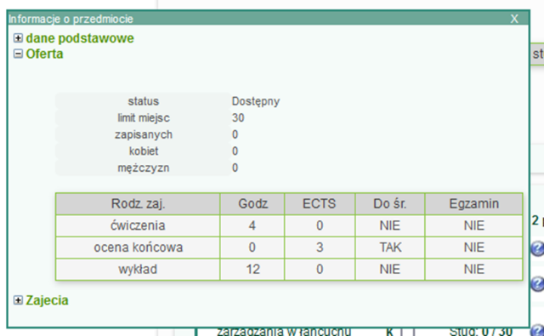

ECTS: 2 – informs how many ECTS points can be gained with a given subject.

3. Choice of subjects
3.1 Click on the check box next to the names of the subjects to be selected. Click the [Choose the Selected] button. Selected items will be moved to the right side and placed on the Chosen subjects list, e.g. ELECTIVE SUBJECTS. The system displays the 'Transferred' notice.
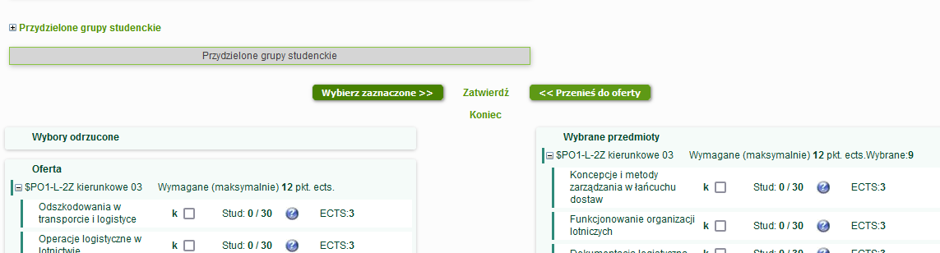

If you have chosen a wrong subject by mistake, select it (click the box next to it), and then the [Transfer to Offer] button. The subject will be transferred back to the Offer.

3.2 To save the selected subjects, click the [Save] button. After confirming the selection, the "changes saved" notice is displayed.

Notice! Very important!
If the choice of subjects is not approved by the student, the choices will not be seen by the dean's office.
Wychodzimy z oferty za pomocą przycisku [Koniec].

- Additional information
4.1 If you choose a different number of subjects than it is scheduled, the system will display the notice: "Incorrect number of ECTS points for ………. Please select the exact number of subjects”.
In this case, you must move some of the subjects from the Chosen subjects list to the Offer list and save it again. If you do not correct your selection, all subjects will be rejected and you will not be enrolled in any subject.

4.2. If a subject is withdrawn from the offer by the dean's office, it is transferred to the Choices rejected box. A subject rejected from the offer cannot be selected.
If you have chosen a subject removed from the offer, please choose another one.

4.3. If the chosen subject is approved by the dean's office, you cannot change your choice (the subject is “inactive”).

